# **PRACTICAL NUMBER: 6B**

**B. Demonstrate the following events in UiPath:**

i) Element triggering event

1. Open UiPath Studio and click on Blank to start a fresh project. Give it a meaningful name. Like Pratical6b.
2. Open Main.xaml from Project tab. On the Designer panel, double click a flowchart activity from the Activities panel.
3. Create a sequence and set it as Start node.
4. Drag and drop a trigger scope activity and in triggers add click trigger – indicate an untitled notepad and specify the mouse button.
5. In actions section’s sequence add a type into activity - indicate an untitled notepad and add some text.

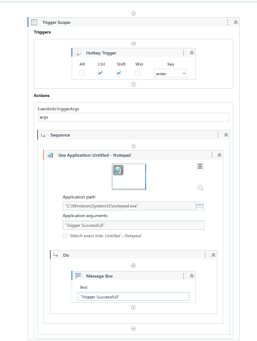

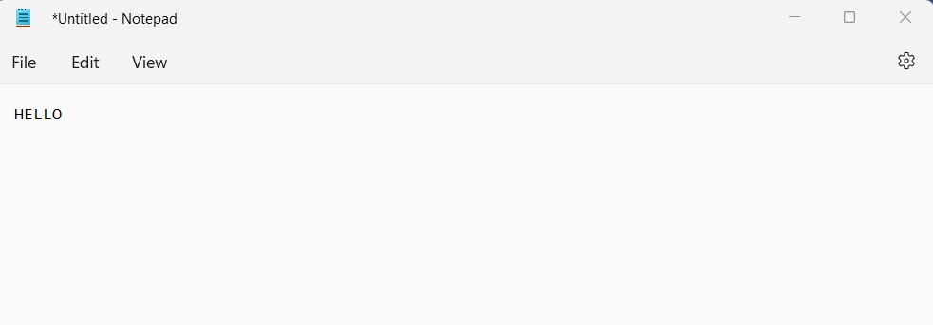

1. Image triggering event
   1. Create another sequence and set this as Start node.
   2. Drag and drop a trigger scope activity and in triggers section add click image trigger – indicate a region of image and specify mouse button.
   3. In action’s sequence section add a message box and enter some text to display.

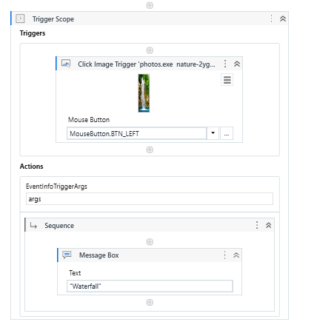

Output:

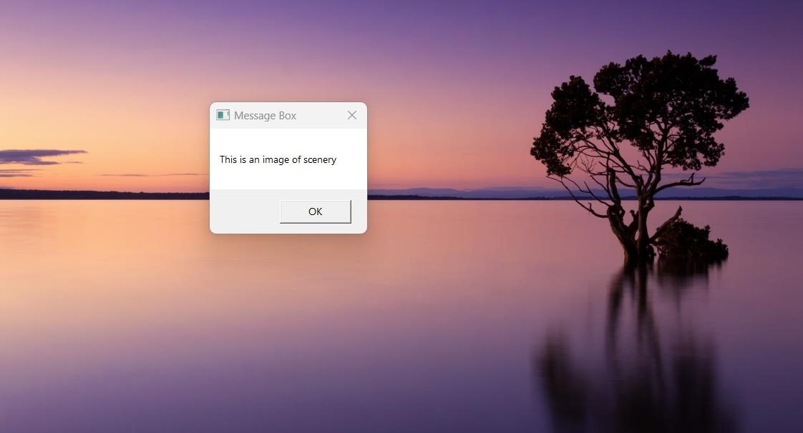

1. System Triggering Event.
   1. Create another sequence and set this as Start node.
   2. Drag and drop a trigger scope activity and in triggers section add system trigger – check both keyboard and mouse from its properties panel.
   3. In action’s sequence section add a Write Line activity and enter some text to display.

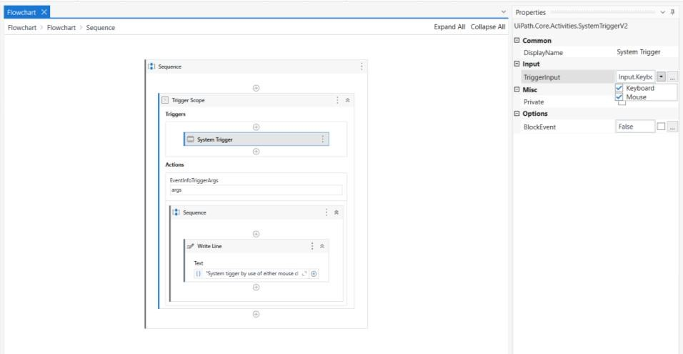

O/P:

